**Introduction to Enterprise Analytics**

# ALY6050 Module 6 Assignment

# Faculty: Prof. Richard He

# 2020 Winter CPS Quarter

# Image result for neu cps

Shraddha Gopalakrishnan [NUID: 001376444]

**Introduction**

A Non-linear program consists of an objective function, few constraints and variable bounds. The difference between linear and non-linear programming are, NLP includes at least 1 non-linear function (might be the objective function or some or all the constraints). This is also an optimization method which is crucial for representing an application correctly as a mathematical detail. Example problems in engineering include analyzing design tradeoffs, selecting optimal designs, computing optimal trajectories, and portfolio optimization and model calibration in computational finance. [1] Let us now dive deep into the logistic analytics of a real-world setting.

**Analysis**

Part 1:

Here we need to determine the number of units to be transported from each source to each destination with each path designating different cost weights and few with no costs. The problem statement implicates 4 sources, 3 intermediary distribution centers and 4 destinations.

We derive the following table using Excel Solver which shows optimal number of units to be shipped from sources to sinks.

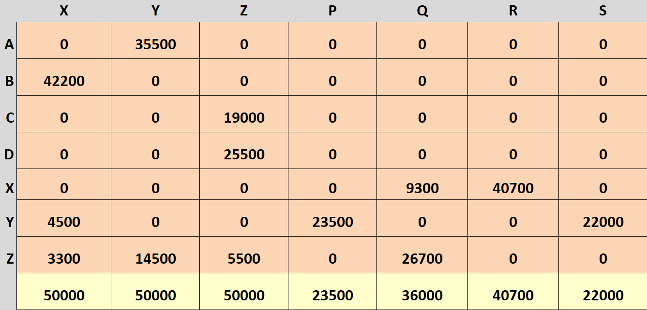

Figure 1:Optimal Unit Numbers

The total optimal transportation cost is **31239300**.

Part 2:

In this part we deal with the demonstration of a Hodrick-Prescott decomposition.

1. The procedure for percolating a trend as a smooth curve from raw data has a long history in statistical science. The initial point of this filter was proposed by Leser (1961), building on the graduation method developed by Whittaker (1923) and Henderson (1924), later this filter got introduced into economics by Hodrick and Prescott in 1980 and 1997. [2] Post that time the Hodrick-Prescott filter is widely used in economics and finance sectors to find and predict business cycles and trends in macroeconomic time series.
2. The Hodrick-Prescott filter separates a time series into growth and cyclical components with

*yt*=*gt*+*ct,*

where *yt* is a time series, *gt* is the growth component of *yt*, and *ct* is the cyclical component of *yt* for *t*=1, ……, *T*.

The objective function for the Hodrick-Prescott filter has the form:

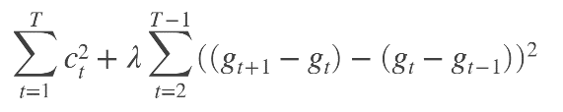

with a smoothing parameter *λ*. The programming problem is to minimize the objective over all *g*1, ….., *gT*.

Benefits:

1. Most popular tool for trend estimations related to economics
2. Fast and stable implementation
3. Clear and easy function
4. The choice of *λ* which is the smoothing parameter is user defined

Detriments:

a. The lambda value of 1600 is too low for most time series

b. No data driven

c. Noise in the data is almost normally distributed.

d. Data mined is clearly historical which does not change, and this limits the domain

1. Hodrick-Prescott optimization method in R-

Read the csv file of Honeywell data and extract the columns except for Date into a variable. Next execute the following lines of code:

*install.packages("mFilter")*

*library("mFilter")*

*stock <- hpfilter(log(mydata$Close),freq = 1600, type=c("lambda","frequency"),drift=FALSE)*

*stock*

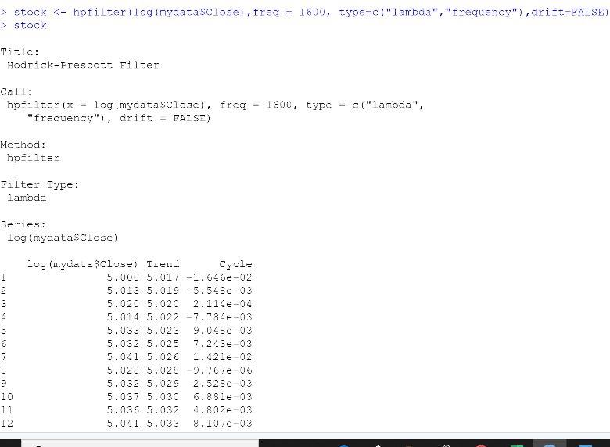

The output is as shown besides. The logarithmic series is attained in two columns- One for Trend and one for Cycle. 253 rows are inherited. The same when done in excel does not provide a solution as Excel Solver has constraint restrictions.

Figure 2: R output for hpfilter function

1. 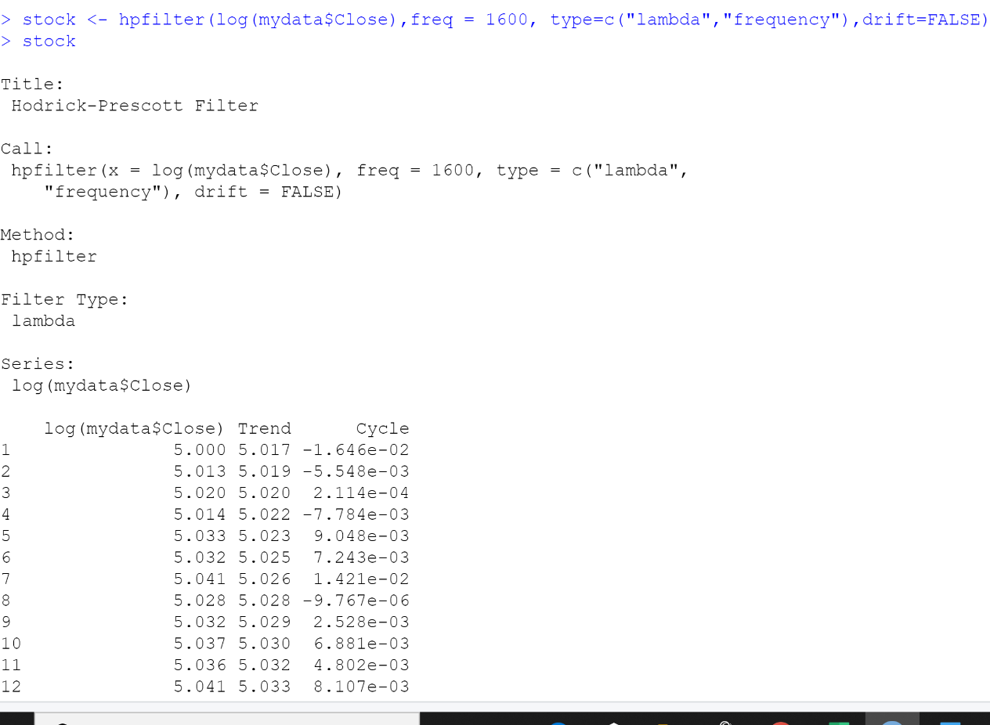We get the log data series of time and the Trend column with statistical values. Cycle values are evaluated as difference between the original time data series and trend. Hence this helps in minimizing our data which is our aim in performing Hodrick-Prescott filter.

Figure 3: Trend Component

1. Line plots of original time series with trend component:

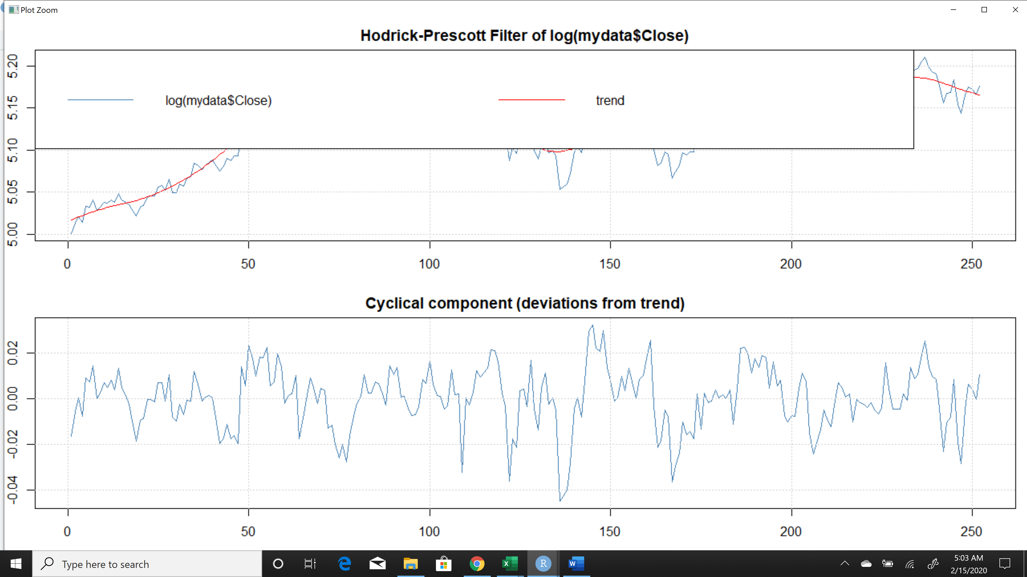

Figure 4: HP Graph 1

The logarithm of data series and trend are shown in the first half of the graphical representation with blue and red colored lines respectively. The pattern is seen to gradually rise with time and occasionally decrease with similar periodicity.

The cyclical component shows us how far the data points are deviated from the primary data.

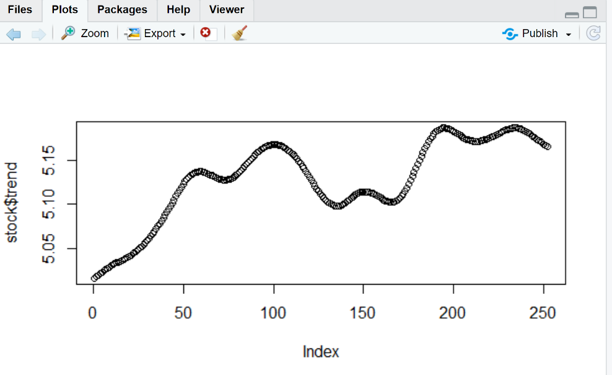

Figure 5: Trend Plot

This is the trend portion of the time series and looks very peculiar.

The trend element of the stocks obtained can be viewed in different forms as follows:

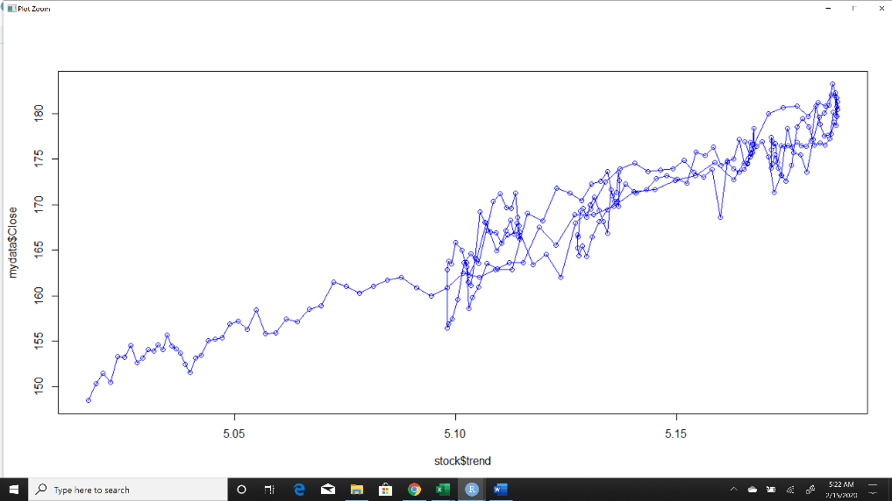

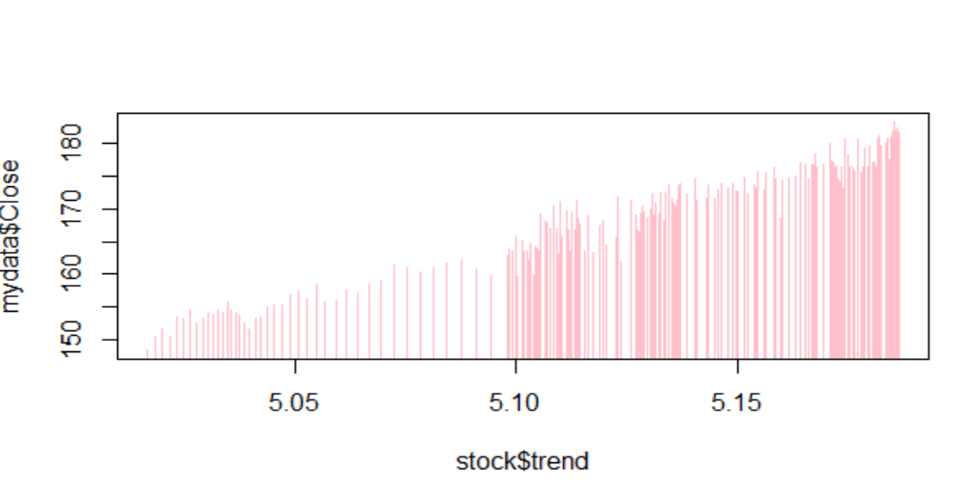This filter determines the quarterly trend of a time series by reducing the importance of short-term stock price fluctuations.

**Conclusion**

Through this experiment, we successfully learned about the Hodrick-Prescott filter as a tool to commonly use in economics and statistics. The decomposition technique is basically a data-smoothing technique which helps in removal of unwanted noise. The HP filter is commonly applied during analysis to remove short-term fluctuations associated with the business cycle. Removal of these short-term fluctuations reveals long-term trends. [2] As the phrase states- Every coin has two sides; given the merits we have lots of drawbacks for HP filter as well. The first proposal is that the filer produces outcomes that have no basis in the process of generating data. It also states that the values that are filtered at the sample's end are totally different from those in the middle.[1]

We converted the additive model into a multiplicative model by applying the decomposition filter. We reviewed formulating and solving integer and binary programming problems by using the Excel Solver add-in and R programming, and apply such formulations to project selection, investment, assignment, scheduling, transportation, and transshipment problems. After this, we formulated and solved general nonlinear programming problems, quadratic programming problems by using Excel and R accordingly. Application of least squares formulations were seen and the use of it in prediction models such as regression was observed. Finally, we saw the application of quadratic programming formulations to problems in economics, finance, and agriculture. [1]

In the last week of the course, we saw the business strategies and actions required to ace descriptive, heuristic and prescriptive analytics. We can now incorporate general industry practices in end-to-end analytics development cycles, including, data management data engineering, analytics modeling, optimization, (e.g. risk minimization) and strategic development.

With this Capstone project, we now are able to understand and interpret optimizing shipments with the use of non-linear programming models in real-world applications. The logistic scenario provided was successfully interpreted. Lastly, we did research o the Hodrick-Prescott filter to a time series data of stocks.

**References**

[1] Hamilton, J. (2017). Why You Should Never Use the Hodrick-Prescott Filter.

[2] Figure 2f from: Reshchikov A, van Achterberg K (2014) Review of the genus Metopheltes Uchida, 1932 (Hymenoptera, Ichneumonidae) with description of a new species from Vietnam. <https://neos-guide.org/content/nonlinear-programming>